

??? Date

Food and Drug Administration
Center for Devices and Radiological Health
510(k) Document Mail Center (HFZ-401)
9200 Corporate Boulevard,
Rockville, Maryland 20850

RE: ABBREVIATED 510(k) for MedCommons™ Open Radiology Gateway

Dear Sir:

MedCommons, Inc. intends to market the Open Radiology Gateway, a medical image viewer.
The enclosed material is submitted consistent with:
- 21 CFR 807
- FDA’s guidance, How to Prepare an Abbreviated 510(k)’s, and
- FDA’s Guidance for the Submission of Premarket Notifications for Medical Image Management Devices

If there are questions about this submittal, please contact Chas Burr of SoftwareCPR, Inc.

Chas Burr
SoftwareCPR, Inc.
11 Mystic Avenue
Winchester, MA 01890-2920

email: cburr@softwarecpr.com
cell phone: 781-789-1646
efax: 781-723-2422

Respectfully yours,

Bill Donner
President

cc:
Chas Burr, SoftwareCPR, Inc.

Enclosure:
Two copies of the Abbreviated 510(k) for MedCommons™ Open Radiology Gateway

Table of Contents

 | Section | Page
 | Abbreviated 510(k) Cover Sheet / Cover Letter
 | Table of Contents
A. | General Information | 4
B. | Administrative Information | 6
1. | 510(k) Summary | 7
2. | FDA Indication for Use Form | 9
3. | Truthful and Accurate Statement | 10
C. | Device Description | 11
1. | Summary of Functions | 11
2. | Diagram of Major Components | 13
3. | Technical Characteristics and Principles of Operation
4. | Specifications
D. | Testing
E. | Comparison to Legally Marketed Device
F. | Labeling
1. | Promotional Materials
2. | User’s Manual
 | Indications for Use
 | Cautions and Warnings
 | Product Specifications
 | Operating Instructions
 | Quality Assurance Procedures
3. | Images
G. | Software Information
1. | Functions Performed by Software
2. | Software Development Methods
3. | Hazard Analysis
4. | Software Test Procedures
5. | Software Certification | 33
H. | Declaration of Conformity to Recognized Standards
 | DICOM Conformance Statement

A. General Information

1. Name and address of manufacturer
MedCommons, Inc.
52 Marshall Street
Watertown, MA 02472

2. Establishment registration number
Pending

3. Name, title, and phone number of contact
For review questions regarding this 510(k) submittal:
Chas Burr
Consultant
SoftwareCPR, Inc.
11 Mystic Avenue
Winchester, MA 01890-2920

781-789-1646
cburr@softwarecpr.com

For ongoing questions:
Adrian Gropper, MD
Chief Medical Officer
MedCommons, Inc.
52 Marshall Street
Watertown, MA 02472

617-571-3857
agropper@medcommons.org

4. Trade name and common name of device
Trade Name: MedCommons™ Open Radiology Gateway
Common Name: Medical image viewer software

5. Classification of the device
Classification Name: Picture Archiving and Communications System
Classification Panel: Radiology
CFR Section: 21 CFR 892.2050
Class: II
Product Code: LLZ

6. Intended use
MedCommons™ Open Radiology Gateway is a software application for viewing medical images. Typical MedCommons™ Open Radiology Gateway users are healthcare professionals, such as, clinicians, radiologists, and technologists.

MedCommons™ Open Radiology Gateway receives, communicates, and displays digital images and data from various types of imaging and image processing system, such CT, MR, US, RF units, computed and direct radiographic devices, scanners, imaging gateways and image processing sources). MedCommons™ Open Radiology Gateway can be integrated with an institution’s HIS or RIS, linking or transferring images and data into electronic patient records.

7. Substantially equivalent device
The MedCommons™ Open Radiology Gateway is substantially equivalent to the eFilm Workstation, which was cleared in 510(k)’s K020995 and K012211.

8. Applicable mandatory and voluntary standards
DICOM (Digital Imaging and Communications in Medicine)
JPEG (Joint Photographic Experts Group)

B. Administrative Information

The following pages are three FDA forms:
- 510(k) Summary
- Indication for Use Statement
- Truthful and Accurate Statement

510(k) Summary for the MedCommons™ Open Radiology Gateway
This 510(k) summary of safety and effectiveness information complies with 21 CFR 807.92.

Submittal information:
Manufacturer:
MedCommons, Inc.
52 Marshall Street
Watertown, MA 02472

Contact person:
Adrian Gropper
Chief Medical Officer
MedCommons, Inc.
52 Marshall Street
Watertown, MA 02472

(617) 571-3857

Device name and classification
Proprietary Name: MedCommons™ Open Radiology Gateway
Classification Name: Picture Archiving and Communications System
Classification Panel: Radiology
CFR Section: 21 CFR 892.2050
Class: II
Product Code: LLZ

Substantial Equivalence
The MedCommons™ Open Radiology Gateway is substantially equivalent to the eFilm Workstation, which was cleared in 510(k)’s K020995 and K012211.

Device Description
MedCommons™ Open Radiology Gateway is a component of a Picture Archiving and Communications System (PACS). MedCommons™ Open Radiology Gateway is a software application that provides image viewing and manipulation in a diagnostic imaging setting. The functions of this application are applied to medical images that are acquired and stored on an image server in DICOM and/or other proprietary formats. MedCommons™ Open Radiology Gateway can also transfer DICOM 3.0 images over a medical imaging network, as well as export images to applications in JPEG and/or proprietary formats.

Intended Use
MedCommons™ Open Radiology Gateway is a software application for viewing medical images. Typical MedCommons™ Open Radiology Gateway users are healthcare professionals, such as, clinicians, radiologists, and technologists.

MedCommons™ Open Radiology Gateway receives, communicates, and displays digital images and data from various types of imaging and image processing system, such CT, MR, US, RF units, computed and direct radiographic devices, scanners, imaging gateways and image processing sources). MedCommons™ Open Radiology Gateway can be integrated with an institution’s HIS or RIS, linking or transferring images and data into electronic patient records.

Comparison to the predicate device
The MedCommons™ Open Radiology Gateway and the eFilm Workstation are both software applications intended for viewing medical images stored in PACS systems. They have similar features and are substantially equivalent in safety and effectiveness.

Indications for Use
510(k) Number (if known): ___________
Device Name: _ MedCommons™ Open Radiology Gateway ______
Indications for Use:
MedCommons™ Open Radiology Gateway is a software application for viewing medical images. Typical MedCommons™ Open Radiology Gateway users are healthcare professionals, such as, clinicians, radiologists, and technologists.

MedCommons™ Open Radiology Gateway receives, communicates, and displays digital images and data from various types of imaging and image processing system, such CT, MR, US, RF units, computed and direct radiographic devices, scanners, imaging gateways and image processing sources). MedCommons™ Open Radiology Gateway can be integrated with an institution’s HIS or RIS, linking or transferring images and data into electronic patient records.

Prescription Use ___X____  (Part 21 CFR 801 Subpart D) | AND/OR | Over-The-Counter Use _______  (21 CFR 807 Subpart C)
(PLEASE DO NOT WRITE BELOW THIS LINE-CONTINUE ON ANOTHER PAGE OF NEEDED)

Concurrence of CDRH, Office of Device Evaluation (ODE)

Truthful and Accurate Statement

I certify in my capacity as Quality Manager and Official Correspondent of MedCommons, Inc., I believe to the best of my knowledge that all data and information submitted in this premarket notification are accurate and that no material fact has been omitted.

______________________________ _______________________
Susan Belanich Date of signature

C. Device Description

1. Summary of Functions
- Import and export of medical imaging studies from modalities, PACS and workstations
- Selection, grouping, and editing of medical imaging study contents
- Viewing of medical images for both review and diagnostic indications
- Annotation and characterization of images and imaging studies for clinical referral
- Communication of medical imaging studies
- Storage of medical imaging studies
- Tracking and status display of referral activities
- Authentication and authorization of users and enforcement of security policies

2. Diagram of Major Components
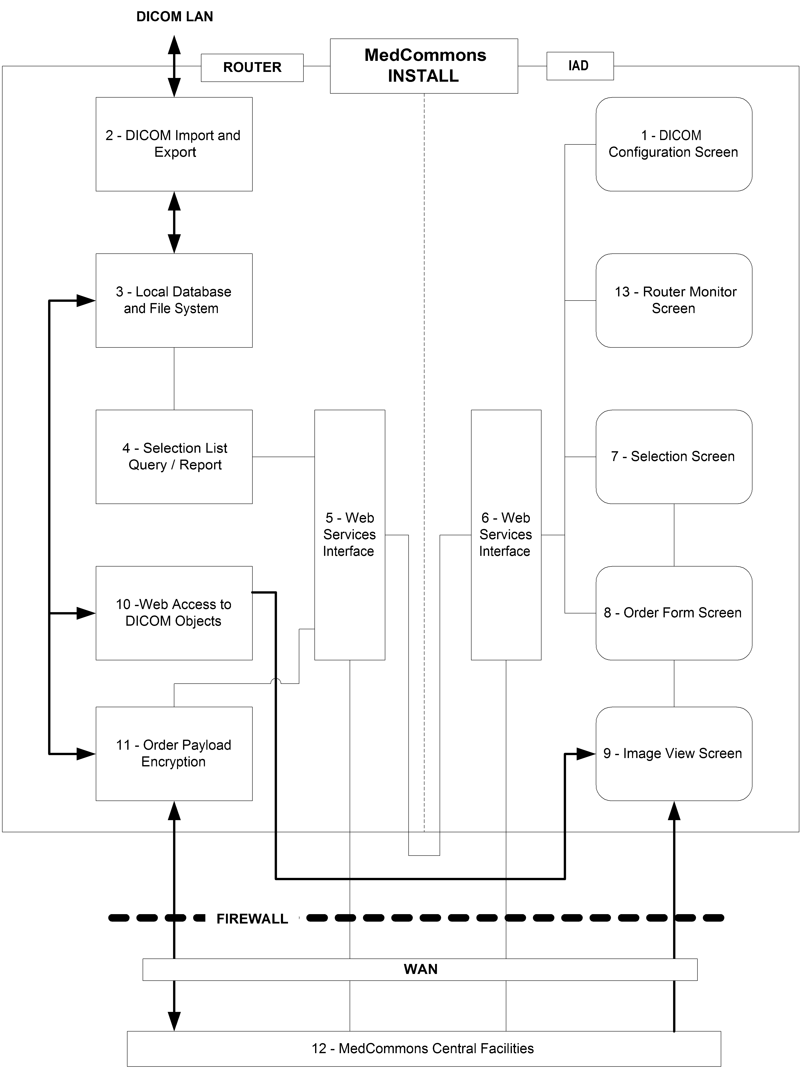

Figure 1

3. Technical Characteristics and Principles of Operation
Gateway is a stand-alone software package which can be used on more than one hardware platform. As long as minimum hardware requirements are met, the user is free to choose their own hardware platform. It is the user’s responsibility to choose image display hardware that is of adequate quality and properly calibrated for the specific clinical application and protocol.

Both systems allow digital image processing and measurement capability. Both systems can transmit to remote viewing stations over a medical imaging network.

Gateway does not contact the patient, nor does it control any life-sustaining devices. A physician providing ample opportunity for competent human intervention interprets images and information being displayed.

Numbers refer to Figure 1 – Major Components and Architecture

The pre-requisite is a computer on the institutional DICOM LAN under the control of a User that has DICOM PACS access privileges. For example, the user would be allowed by the institution to install and operate an eFILM Workstation.

Upon satisfactory Registration with the MedCommons Central Facilities [12] the User is allowed to download a MedCommons Installer to their computer. The Installer installs two distinct components – the Router and the IAD on the computer. In alternate hardware configurations, the Router is installed on a separate computer, the IAD is replaced by a Web browser or the User orders a MedCommons Tablet with software installed.

1 – A DICOM Configuration Screen [1] configures the Router to join the DICOM network.
2 – DICOM Query, Move, etc… to the DICOM Engine [2] are used to populate and update a Local Database [3] of imaging studies in accordance to the user’s privileges and role relative to the PACS.
3 – The Local Database and File System [3] provides temporary storage of imaging studies and items such as pending Orders that might be the subject of a transfer.
4 – A Selection List Query [4] responds to parameters entered by the User on Selection Screen [7] with a Report that populates a list on Selection Screen [7] with items from Database [3]. Alternative embodiments would build a Selection Report by a Query to the PACS directly.
5 – Web Services Interface [5] and [6] relay messages between the Router and IAD using standard protocols.
6 - The Router can be located on a different computer from the IAD and multiple IAD’s can communicate with multiple Routers.
7 – The User picks one or more items from the Selection Screen [7]. Each item typically represents a DICOM Study.
8 – The item(s) selected populate the payload field of an instance of an Order as displayed on the Order Form Screen [8]. Information such as the Patient’s Name and Referring Physician are derived from the DICOM Study metadata and can be used to populate other fields of the Order Form. Furthermore, the Order Form Screen can use the Web Services Interface [6] to fetch additional information from MedCommons Central [12] by using Patient, Physician and other information such as Procedure that is available in the DICOM metadata.
9 – An Image View Screen [9] is available to the User for quality control purposes during the Order creation process.
10 – A Web Access to DICOM Objects (WADO) [10] module supports the View Screen [9]. Alternative embodiments would have DICOM access to the Router by a Diagnostic or 3D Workstation (e.g.: eFILM, Voxar) or could access images directly from the local Database and File System [3].
11 – Finalization of the Order, as communicated via the Web Services Interface, triggers the Order Payload Encryption [11] to package the payload and Order information for transport over the WAN to the MedCommons Central Facilities [12].
12 – The MedCommons Central Facilities [12] provide temporary buffering and routing for studies on the way to Routers at other facilities.
- Payload elements are typically decrypted and re-encrypted with keys that are specific to the destination Router.
- Payload metadata may be examined to assist in routing if the Order Form itself does not have sufficient information.
- Payload images and reports are made available directly to Web browsers using a WADO module at the Central Facility that uses technology similar to that used in the Router..
- The Central Facility keeps a HIPAA Log of transfers that is accessible to the Patient and to other authorized Users.
- The Central Facility provides long-term archiving.

4. Specifications
Gateway is a software application. It has no equipment specifications consistent with the intent of section C.4 of FDA’s Guidance for the Submission of Premarket Notifications for Medical Device Image Management Devices.

Gateway is specified to operate on:
Hardware:
Pentium III or compatible processor
512 MB RAM
100 MB Hard Drive Space
Minimum Display Resolution 1024x768 pixels
Color Table Resolution 24 or 32bits per pixel

Operating System
Windows XP
Microsoft IE 5 or higher

D. Testing

E. Comparison to Legally Marketed Device

Category | eFilm Workstation | MedCommons Gateway
PACS Functionality | Yes | Yes
Diagnostic Image Display | Yes | Yes
Image Manipulation and Annotation | Yes | Yes
Image Interpolation and Processing | Yes | Yes
Software Only | Yes | Yes
Install from the Web | Yes | Yes
Documentation Online | Yes | Yes
Centralized Management | Optional | Optional
Software Source Code Online | No | Yes

The Gateway is similar to the predicate device in function, labeling and intended use. The principal difference between the devices is in production and quality management procedures due to the extensive use of Open Source Software in the MedCommons Gateway. MedCommons expects that availability of source code will enable peer review that will improve quality, safety and effectiveness of the MedCommons Gateway more effectively as compared to the predicate device and other complex medical devices that enforce secrecy of important and increasingly risky software components.

F. Labeling

Promotional Materials

Open Source Software
The MedCommons™ Open Radiology Gateway (“Gateway”) is Open Source Software.

Medical images are increasing in resolution and accuracy and play an ever more important role in medical care. Improved resolution and accuracy resonate with increasing computer processing capacity to enhance diagnosis, treatment planning and evidence-based medicine.

Greater risk comes hand-in-hand with greater importance. MedCommons is founded on the belief that open peer review of software and open access to software processing will be required to manage a new generation of health care software.

The MedCommons™ Open Radiology Gateway is a medical device for diagnostic image viewing based on Open Source Software. High resolution data sets such as multi-detector CT and modern MR increasingly benefit from sophisticated processing to display the data quickly and efficiently. Whether as simple as interpolation between pixels or as complex as tracking the location of an aortic stent, the methods for image manipulation between from the acquisition protocols to the physician’s user interface are becoming too important to keep secret.

Open Source Software architecture, particularly in the image and image interpretation pipeline, enables peer review and incremental extension of functionality. Because Open Source methods allow for public visibility at all stages of the software life cycle, the bugs are public and innovators are less prone to introducing errors when they re-invent or reverse engineer the functionality of critical subsystems.

Open Source Software also provides powerful tools for data interchange and archival storage. Open Source Software protects the data by enabling interchange between vendors even when standards-compliance is imperfect or when financial difficulties make vendor support impractical.

As a complete image acquisition, management and display device in a format accessible to typical clinicians, MedCommons is providing an Open Source Software alternative for physicians to use as they take increasing responsibility for understanding and using ever more sophisticated software-based tools.

Draft User Guide

Product Identification
MedCommons Open Radiology Gateway User Guide
V 0.4
Part Number 01-0001
May 13, 2004

Copyright Notice
Copyright © 2004 MedCommons Inc., 52 Marshall St. Watertown, MA 02472

All Rights Reserved. Portions of this document may be put into the public domain under the Creative Commons guidelines.

This user guide has been produced to assist in providing instruction for the MedCommons Open Radiology Gateway product. Every effort has been made to make the information in this guide as accurate as possible. The authors of this guide shall have neither liability nor responsibility to any person or entity with respect to any loss or damages in connection with or arising from the information contained in this guide.

Trademarks
MedCommons, Open Radiology and MedCommons Gateway are trademarks of MedCommons Inc. Any additional software products named in this document are claimed as trademarks or registered trademarks of their respective companies.

Contact Information
MedCommons Inc.
52 Marshall St.
Watertown, MA 02472
Phone 617 395 6744
Fax 617 924 5329
www.medcommons.net
mailto: support@medcommons.net

Before you begin…
This software is intended for use by licensed clinical practitioners who are trained appropriately in the software’s functions and applications and are aware of its limitations.
Poor ambient conditions (e.g.: excessive room light), improper display calibration (e.g.: excessive contrast), careless application of image manipulation tools (e.g.: window and level adjustment) and inadequate familiarity with the user interface (e.g.: not reviewing all available information) can all result in incorrect interpretations of an imaging study.

The user should also be aware that the image information being processed by the device is potentially incomplete on does not adequately conform to the standards as implemented by the device. To mitigate the impact of these problems, a qualified user is expected to take into account the underlying imaging protocols and to recognize the absence or gross corruption of information.

This device is designed, manufactured and tested to reduce the risk of subtle and serious corruption of labels and image contents. Internal checks and redundant external labels are used to reduce the likelihood of misinterpretation due to internal software errors but these are not foolproof and cannot compensate for bad information coming into the device.

On occasion, interpolated (magnified) data may introduce image artifacts which should not be interpreted as real pathology. When artifacts are suspected, the trained user may be able change the magnification ratio or window/level setting to help differentiate artifacts from pathology.

System Requirements
Hardware:
Pentium III or compatible processor
512 MB RAM
100 MB Hard Drive Space
Minimum Display Resolution 1024x768 pixels
Color Table Resolution 24 or 32bits per pixel

Operating System
Windows XP
Microsoft IE 5 or higher

Please check the support and help files at www.medcommons.net for the most up-to-date system requirements.

Software License
This License Agreement ("Agreement") is a legal agreement between you (either an individual or a legal entity) ("Licensee", "you", "your", as context requires) and MedCommons Inc., a corporation having its principal place of business at 52 Marshall St. Watertown MA. BY INSTALLING, COPYING, DOWNLOADING, ACCESSING, OR OTHERWISE USING THE SOFTWARE, YOU AGREE TO BE BOUND BY THE FOLLOWING TERMS AND CONDITIONS. PLEASE READ THESE TERMS AND CONDITIONS CAREFULLY AS THEY GOVERN YOUR USE OF THE SOFTWARE. If you do not agree to the terms and conditions of this Agreement, please do NOT install the Software and immediately destroy any copies of the Software and Documentation in your possession.

Open Source Licenses
This software is licensed under various Open Source licenses including The GNU General Public License (GPL) Version 2 and GNU Lesser General Public License Version 2.1 as published and Copyright Free Software Foundation, Inc. 59 Temple Place, Suite 330, Boston, MA 02111-1307 USA.

Source code is available for download directly from the Support section at www.medcommons.net. Individual Copyrights and Software Licenses are determined by the specific contributors of each of the components of this software distribution and can be reviewed as attached to each source file.

Non-Open Source Licenses
Some components of this software distribution are not Open Source and may be licensed separately by MedCommons and, where applicable, passed trough by MedCommons as required by its suppliers and licensors and in a manner that is compatible with the Open Source components of this distribution. In other words, software in this distribution is free as long as the terms of all licenses (MedCommons or other) listed or referenced in this User Manual are met.

License Restrictions
You agree that you shall only use the Software and Documentation in a manner that complies with all applicable laws, regulations and the like in the jurisdictions in which you use the Software and Documentation, including, but not limited to, applicable restrictions concerning medical uses and copyright and other intellectual property rights.

The Software or the use of the Software may be subject to legal or regulatory provisions related to products used in the health care. Prior to using the Software, it is your responsibility to ensure that your use of the Software will not violate any legal or regulatory provisions. Please contact MedCommons to determine the most recent information regarding legal and regulatory approvals.

Updates and Bugs
MedCommons reserves the right at any time to, but is not obligated to, correct errors, alter features, specifications, capabilities, functions, release dates, general availability or other characteristics of the Software ("Updates"). You agree that you may not have access to such Updates without separate payment or through a separate support agreement. You agree and understand that although MedCommons takes steps to prevent errors, the Software may contain errors affecting proper operation.

Title
MedCommons retains all right title and interest in and to the trademarks, trade names, logos and icons (collectively “Marks”) used in or identifying the Software or its features and you may not use such Marks without the prior written consent of MedCommons.

No Warranty
DISCLAIMER OF WARRANTY & LIMIT OF LIABILITY. TO THE MAXIMUM EXTENT PERMITTED BY APPLICABLE LAW, MEDCOMMONS EXPRESSLY DISCLAIMS ALL WARRANTIES, INCLUDING WITHOUT LIMITATION ANY IMPLIED WARRANTIES OF MERCHANTABILITY, FITNESS FOR A PARTICULAR PURPOSE, TITLE OR NONINFRINGEMENT TO THE MAXIMUM EXTENT PERMITTED BY APPLICABLE LAW. IN NO EVENT SHALL MEDCOMMONS BE LIABLE FOR ANY CONSEQUENTIAL, INCIDENTAL, INDIRECT, SPECIAL, PUNITIVE, OR OTHER DAMAGES WHATSOEVER (INCLUDING, WITHOUT LIMITATION, DAMAGES FOR LOSS OF PROFITS, SERVICE INTERRUPTION, LOSS OF INFORMATION, OR OTHER PECUNIARY LOSS) ARISING OUT OF THIS AGREEMENT OR THE USE OF OR INABILITY TO USE THE SOFTWARE OR DOCUMENTATION, EVEN IF MEDCOMMONS HAS BEEN ADVISED OF THE POSSIBILITY OF SUCH DAMAGES. MEDCOMMONS'S TOTAL LIABLITY FOR ANY DIRECT DAMAGES SHALL NOT EXCEED FIVE DOLLARS ($5.00). BECAUSE SOME JURISDICTIONS DO NOT ALLOW THE EXCLUSION OR LIMITATION OF LIABILITY FOR CONSEQUENTIAL OR INCIDENTAL DAMAGES, THE ABOVE LIMITATION(S) MAY NOT APPLY TO YOU.

Indemnification
The Software is not intended to replace the skill and judgment of a qualified medical practitioner and should only be used by people that have been appropriately trained in the Software's functions, capabilities and limitations. You agree to hold harmless, indemnify and defend MedCommons, its suppliers, officers, directors and employees, from and against any losses, damages, fines and expenses (including attorneys' fees and costs) arising out of or relating to your use of the Software. THE ENTIRE RISK ARISING OUT OF YOUR USE OF THE SOFTWARE AND DOCUMENTATION REMAINS WITH YOU.

Termination
This License Agreement will automatically terminate if you fail to comply with any term hereof. No notice shall be required from MedCommons to effect such termination.

Export Restriction
Parts of this distribution may be subject to the limitations on transfer imposed by the United States' Export Administration Act of 1979 as amended. You agree that you will not, and will not assist or permit others under your control and direction to, export the software or documentation or any part thereof, in contravention of these laws or the related rules and regulations.

Miscellaneous
This Agreement shall constitute the complete and exclusive agreement between the Parties, notwithstanding any variance with any other written instrument submitted by you, whether formally rejected by MedCommons or not. The terms and conditions contained in this Agreement may not be modified except in a writing duly signed by you and an authorized representative of MedCommons. This Agreement is personal to you, and may not be assigned without MedCommons' express written consent. If any provision of this Agreement is held to be unenforceable for any reason, such provision shall be reformed only to the extent necessary to make it enforceable, and such decision shall not affect the enforceability of such provision under other circumstances, or of the remaining provisions hereof under all circumstances. This Agreement shall be governed by the laws of the Commonwealth of Massachusetts, without regard to conflicts of law provisions, and you hereby consent to the exclusive jurisdiction of the courts sitting in Massachusetts. To the extent that you have breached or have indicated your intention to breach this Agreement in any manner which violates or may violate MedCommons' intellectual property rights, or may cause continuing or irreparable harm to MedCommons (including, but not limited to, any breach that may impact MedCommons' intellectual property rights), MedCommons may seek injunctive relief, or any other appropriate relief, in any court of competent jurisdiction.

MedCommons Open Radiology Gateway Overview

Open Source Software
The MedCommons™ Open Radiology Gateway (“Gateway”) is Open Source Software.

Medical images are increasing in resolution and accuracy and play an ever more important role in medical care. Improved resolution and accuracy resonate with increasing computer processing capacity to enhance diagnosis, treatment planning and evidence-based medicine.

Greater risk comes hand-in-hand with greater importance. MedCommons is founded on the belief that open peer review of software and open access to software processing will be required to manage a new generation of health care software.

The MedCommons™ Open Radiology Gateway is a medical device for diagnostic image viewing based on Open Source Software. High resolution data sets such as multi-detector CT and modern MR increasingly benefit from sophisticated processing to display the data quickly and efficiently. Whether as simple as interpolation between pixels or as complex as tracking the location of an aortic stent, the methods for image manipulation between from the acquisition protocols to the physician’s user interface are becoming too important to keep secret.

Open Source Software architecture, particularly in the image and image interpretation pipeline, enables peer review and incremental extension of functionality. Because Open Source methods allow for public visibility at all stages of the software life cycle, the bugs are public and innovators are less prone to introducing errors when they re-invent or reverse engineer the functionality of critical subsystems.

Open Source Software also provides powerful tools for data interchange and archival storage. Open Source Software protects the data by enabling interchange between vendors even when standards-compliance is imperfect or when financial difficulties make vendor support impractical.

As a complete image acquisition, management and display device in a format accessible to typical clinicians, MedCommons is providing an Open Source Software alternative for physicians to use as they take increasing responsibility for understanding and using ever more sophisticated software-based tools.

Indications for Use
MedCommons™ Open Radiology Gateway is a software application for viewing medical images. Typical MedCommons™ Open Radiology Gateway users are healthcare professionals, such as, clinicians, radiologists, and technologists.

MedCommons™ Open Radiology Gateway receives, communicates, and displays digital images and data from various types of imaging and image processing system, such CT, MR, US, RF units, computed and direct radiographic devices, scanners, imaging gateways and image processing sources). MedCommons™ Open Radiology Gateway can be integrated with an institution’s HIS or RIS, linking or transferring images and data into electronic patient records.

Registration and Installation

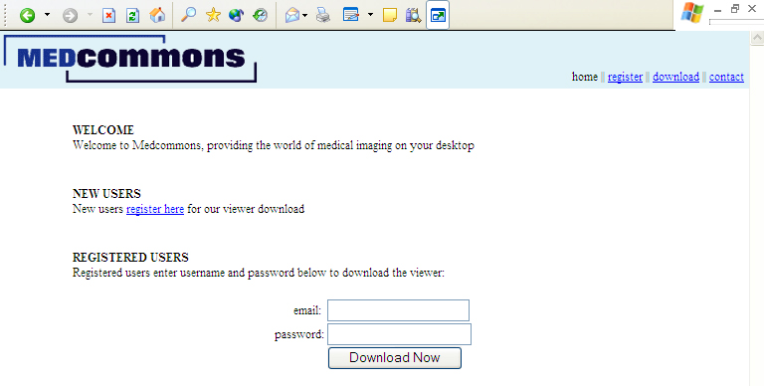

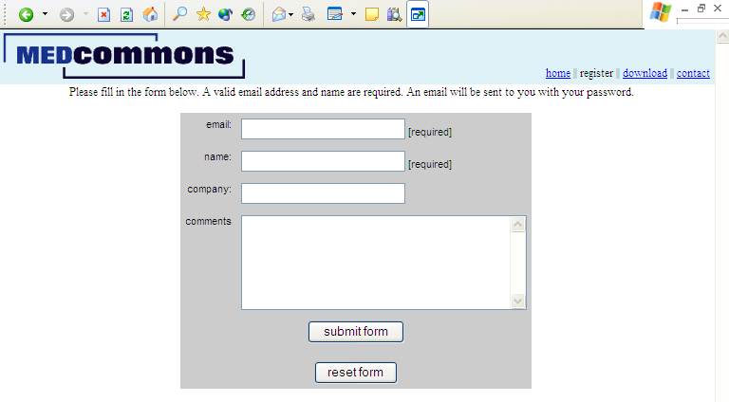

Configuration

Uninstalling

The WADO Viewer

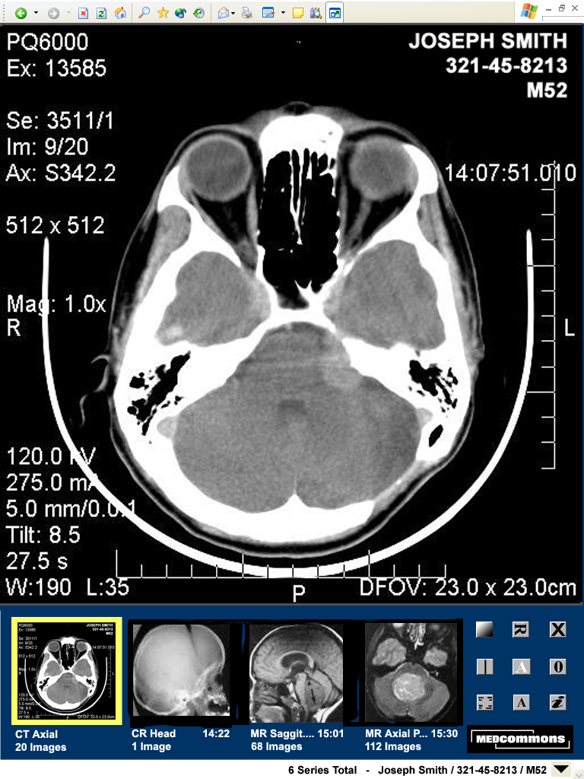

Using the Tools
Image display is controlled primarily by gestures made with a mouse or equivalent pointing tool such as the “pen” of a tablet PC. Some actions have keyboard alternatives.

The two principal gestures are click and drag. A click is typically used to select or activate. Drag is the gesture that draws an imaginary line or rectangle across the screen. Drag gestures are used to indicate a region or to achieve proportional control.

Gestures cause different actions depending on the region (e.g.: image display, thumbnail display, tool palette, menu) of the screen where they are begun. Most gestures provide the user with visual feedback as they are performed.

- Display Menu
A Display Menu at the bottom of the WADO Viewer lists all of the available series for the current patient / study. A check mark next to an item indicates that the thumbnail for that series is currently displayed.

By default (un-clicked) the Display Menu label shows the total number of series available for the current patient and the patient’s identifying information. This feature allows the patient’s name to be displayed in two places in the viewer for safety reasons. Although the WADO Viewer is designed to operate without scroll bars to ensure that critical information is always on-screen, some browser / screen configurations can automatically introduce scroll bars. Operation of the WADO Viewer on a screen with less than 1024 x 768 pixels is not recommended.

- Scroll Wheel
The Scroll Wheel of the mouse controls the displayed image number in all modes. Keyboard arrow keys can also be used to step through images and series.

- Left Mouse Function
The primary mouse button (typically the left button) toggles between two modes of control for Window / Level or Zoom. Clicking the tool icon toggles the mode and changes the icon to match. Both Window / Level settings and Zoom / Pan settings apply to the display of all images in a series.

Window / Level
In Window / Level mode, a drag across the image defines a region. On mouse-up, the image will be replaced by a matrix of 9 versions of the region. Each version of the region will be a different Window / Level option automatically selected by the software. For reference, the middle image of the matrix (cell # 5) will be rendered with no change in the Window / Level. The options presented in the other 8 cells may depend on the modality of the originated the image and other information derived from the DICOM image header.

A click on a cell of the Window / Level matrix will redraw the entire previous image using the selected Window / Level option. A click on a thumbnail in Window / Level mode will select the new series, replace the image in the display frame and apply the current settings to the image series.

A drag on a cell of the Window / Level matrix will cause the entire matrix to be redrawn as variations from the selected cell. The region itself will be unchanged. The extent of the drag gesture will indicate how large a change is desired.

Zoom
In Zoom mode, a drag across the image defines a region. On, mouse-up, the image will be replaced by a magnified version of the selected region. A frame will appear over the corresponding thumbnail to indicate the location of the magnified region. Enabling image overlay will display the magnification factor.
A click on the image window will toggle the image between full display and magnified display.

A drag across a thumbnail showing the Zoom region frame will pan the frame to adjust the region on display.

Reset
A click on the Reset tool will restore the image display for the currently selected series to the initial defaults. This includes Window / Level and Zoom.

Two consecutive clicks on the Reset Tool will restore the entire study (all series) and other display modes (e.g.: Overlays) to the initial defaults.

Rotate / Flip
Successive clicks on the Rotate / Flip Tool will change the displayed image in sequence. The sequence is 0◦, 90◦, 180◦, 270◦, Flip Horizontal, Flip Vertical and back to 0◦. Rotations apply to all images in a series.

Overlay Show / Hide
This tool toggles the display of information as an overlay on the image. Patient identifying information (Name, ID, Age, Sex) cannot be hidden. The information displayed depends on the modality, the information received and the current display state.

Examples of display state information include: Image #, Window / Level, Lossy Compression Ratio and Magnification Ratio. Scale Bars, if displayed on the Overlay, reflect the current Magnification Ratio.

Compare
This tool launches another instance of the WADO Viewer and automatically selects the most likely series from the same patient and study for initial display. Depending on screen size, screen configuration and user login preferences, the new WADO Viewer instance can be running on the same computer or another computer.

WADO Viewers launched using the Compare tool are automatically linked with respect to the actions of the Mouse Scroll Wheel for image selection.

Annotation Tools
The Annotation tool changes state in sequence to enable Text, Regions, Arrows and Dimensions to be add Annotation Objects to the Annotation Overlay. The Annotation Overlay is associated with a particular image and will not be saved once the WADO Viewer is closed or a new Patient is selected.

The behavior of each Annotation Object may depend on the particular browser in use and some tools may not be available in your browser.

Caution: The position of Annotation Objects is automatically adjusted to reflect Zoom and Pan of an image. This action can cause some annotations to be obscured or to change position relative to each other. If the image Magnification and Pan state are changed, it is the user’s responsibility to verify that the annotations still reflect the user’s clinical intent.

Annotations Show / Hide
This tool toggles the visibility of all of the Annotation Overlays in a study.

View HIPAA Log
This tool displays a page of information including security, transfer and warning notices that apply to the current study.

Exit
This tool will always remove the current patient from display. Depending on configuration, the WADO Viewer window may stay open with no patient or the next patient and study in a sequence will be displayed.

Images
The Gateway software does not know the extent to which an image has been processed before it is received. On-image labeling about processing may be misleading. For example, Gateway could indicate that an image has not been processed, when in fact it had been processed extensively prior to its receipt. The following labeling is in the Users Guide:

The user should also be aware that the image information being processed by the device is potentially incomplete on does not adequately conform to the standards as implemented by the device. To mitigate the impact of these problems, a qualified user is expected to take into account the underlying imaging protocols and to recognize the absence or gross corruption of information.

This device is designed, manufactured and tested to reduce the risk of subtle and serious corruption of labels and image contents. Internal checks and redundant external labels are used to reduce the likelihood of misinterpretation due to internal software errors but these are not foolproof and cannot compensate for bad information coming into the device.

On occasion, interpolated (magnified) data may introduce image artifacts which should not be interpreted as real pathology. When artifacts are suspected, the trained user may be able change the magnification ratio or window/level setting to help differentiate artifacts from pathology.

G. Software Information

1. Functions Performed by the Software

2. Software Development Methods

3. Hazard Analysis

4. Software Test Procedures

5. Software Certification

I certify in my capacity as President of MedCommons, Inc., I believe to the best of my knowledge that the software information in this premarket notification is correct. The testing procedures described in Section G. 4. Software Test Procedures will be used to retest and revalidate the software when it is revised.

______________________________ _______________________
William Donner Date of signature

H. Declaration of Conformity to Recognized Standards

DICOM Conformance Statement

Summary Report of Reliance on Standards
The MedCommmons™ Open Radiology Gateway complies with the FDA Recognized Standards listed below.

NEMA PS3.1 through PS 3.15 2000, Digital Imaging and Communications in Medicine (DICOM) Part 15: Security Profile.

JPEG

SMPTE Test Pattern

Declaration of Conformity to IEC 60601-1

Medical Electrical Equipment - Part 1: General Requirements for Safety, and Amendments 1 and 2

All requirements of this standard were met except for these inapplicable requirements or deviations noted below.

This standard was adapted for application to the O-Arm 5000™ by:

These requirements of the standard are inapplicable to the O-Arm 5000™:

Deviations from the standards and their rationale:

Differences between the tested device and the device to be marketed and a justification of the test results in these area of differences:

Name and address of any test laboratory or certification body involved in determining the conformance of the device to this standard and a reference to any accreditations:

Declaration of Conformity to IEC 60601-1-1

Medical Electrical Equipment - Part 1: General Requirements for Safety;

Safety Requirements for Medical Electrical Systems

All requirements of this standard were met except for these inapplicable requirements or deviations noted below.

This standard was adapted for application to the O-Arm 5000™ by:

These requirements of the standard are inapplicable to the O-Arm 5000™:

Deviations from the standards and their rationale:

Differences between the tested device and the device to be marketed and a justification of the test results in these area of differences:

Name and address of any test laboratory or certification body involved in determining the conformance of the device to this standard and a reference to any accreditations:

